*Florida International University*

*School of Computing and Information Sciences*

CIS 4911 - Senior Capstone Project

Feature Document

User Story #1101

# Creating new Lock & Unlock Mechanism for Projects

**Team Member:**

Joseph Gonzalez

**Product Owner(s)**:

Masoud Sadjadi

**Mentor(s)**:

Mohsen Taheri

**Instructor**: Masoud Sadjadi

# **User Story - Creating Lock & Unlocking Mechanism to Projects**

* As a User I would like to be able to lock projects so that they can no longer be joined

## **Use Case**

**Use Case ID:** (VIP-1101)

**Details:** Create Lock and Unlocking Mechanisms to Projects

**Actor:** Users

**Pre-Condition:**

* A Project has been created and approved on vip.fiu.edu

**Description:**

1. Use Case begins when a CoPI navigates to the admin panel
2. From the admin panel, CoPI navigates to the “Lock/Unlock Projects” dropdown menu
3. From the top dropdown menu they can select a project
4. From the bottom dropdown menu they can select “Active” or “Inactive”
5. Once both items are selected, they can press the green “Change” button to change the status of the project

**Post-Conditions:**

1. If the status was set to “Inactive” users will no longer be able to join the project. When pressing either the join button in the project’s page, or when trying to join the project via the student application
2. If the project was set to “Active” users will now be able to join the project.

**Alternative Course of Action**

N/A

**Exceptions:**

N/A

**Related Use Cases:**

**Decision Support:**

**Frequency:** Medium: This occurs at the request of the product owner

**Criticality:** Medium: These locks prevent projects from being joinable by new members

**Risk:** Low.

**Constraints:**

1. **Usability:** 
   1. No training required
2. **Reliability:** 
   1. Availability – A few times a semester.
3. **Performance:** 
   1. Locks access and update the database within a reasonable time frame
4. **Supportability:**
   1. All modern web browsers should be supported.

**Modification History:**

**Owner:** Joseph Gonzalez

**Initiation date:** 10/17/2016

**Date last modified:** 10/24/2016

**Use Case Diagram**

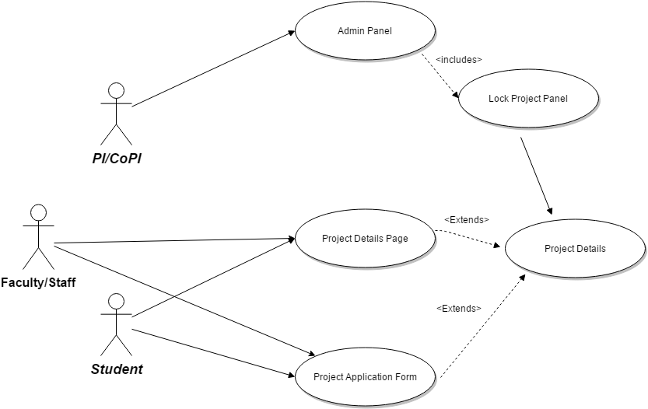

**Sequence Diagram**

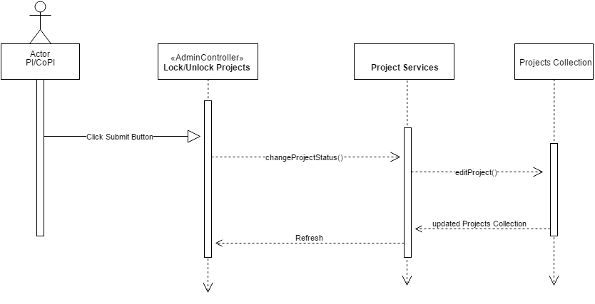

**Class Diagram**

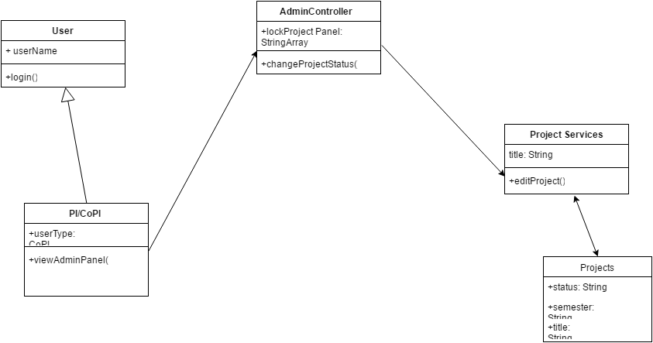

**Unit & Integration Tests:**

**Test Case 1 (Sunny Day)**

**ID: VIP-SD-1101-01**

**Purpose**

* Test that the lock is now working

**Precondition**

* A project has been selected in the admin panel

**Input**

* The projects status is set to inactive

**Expected Result**

* The Database now reflects the changes made in the admin panel

**Actual Result**

* Same as expected.

**Test Case 2 (Sunny Day)**

**ID: VIP-SD-1159-02**

**Purpose**

* Confirm an inactive project cannot be joined

**Precondition**

* Project’s status has been set to inactive

**Input**

* A user attempts to join a project via the project details page or project application form

**Expected Result**

* The site blocks them from joining the project and alerts them of the reason

**Actual Result**

* Same as expected

**User Guide**

Once logged into the site, navigate to the admin panel



From there, scroll down to the “Lock/Unlock Semester” Panel:

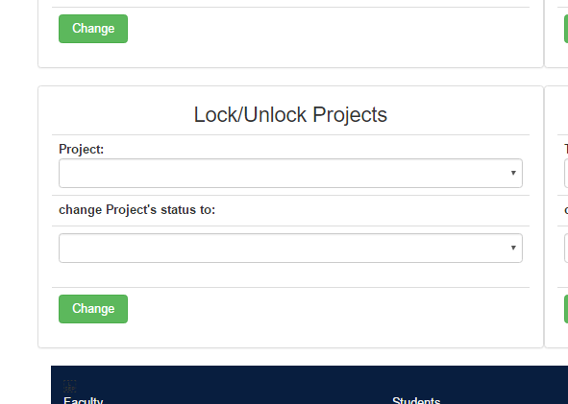

Select an option in the “Project” menu, and an option from the “change Project’s status to” menu. Then click the “Change” button underneath. You have now locked a Project.To test if the lock is working first, try to propose a new project for that locked Semester. In this example we’ve Locked “VIP 5.0”.

Now in the Project’s Page (<http://vip.fiu.edu/#/vip-projects>) we can scroll down and navigate to the VIP 5.0 Project’s detailed page:



From here, note 2 things:



1. The line “This Project is Currently Inactive” above the project title is now there to indicate the project has been locked.
2. When attempting to select the “Join” button, the following message appears

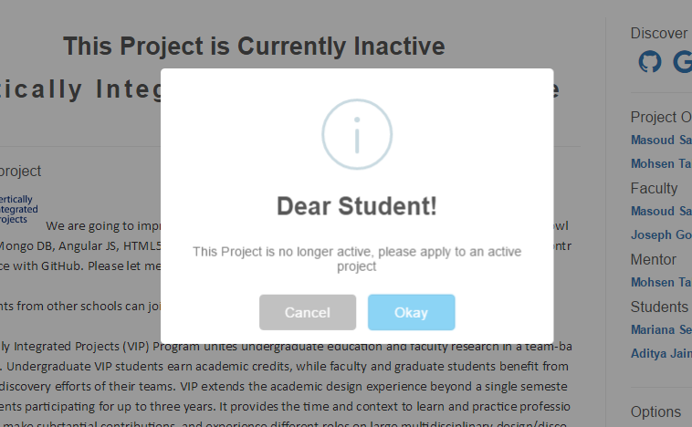

In the Student Application Form (http://vip.fiu.edu/#/studentConfirmation/), also take note that the locked project will no longer appear as an option in the “Projects” dropdown menu:

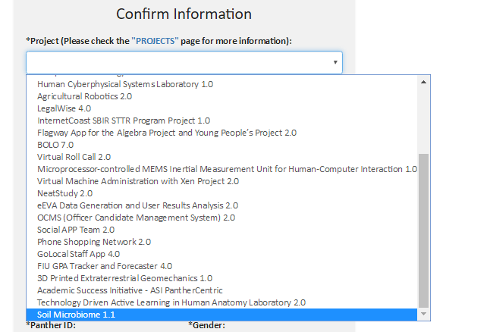

So thus the project is locked and inaccessible by any new members.